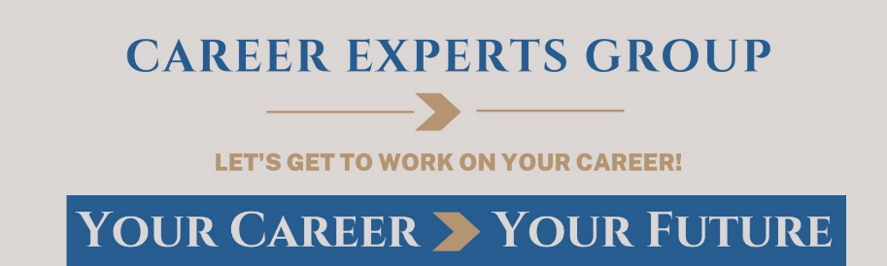
Ask the Experts
September 2022
LinkedIn
Do I really need a LinkedIn profile?

Absolutely! Consider these statistics:
- 59.1% of LinkedIn users are between ages 25 and 34 (Statista).
- 49 million people use LinkedIn to search for jobs every week, 210 million job applications are submitted monthly through LinkedIn, and 6 people are hired every minute on LinkedIn (LinkedIn Pressroom).
- Over 20,000 companies in the U.S. use LinkedIn to recruit (LinkedIn Workforce Report).
- There are 15M+ open jobs on LinkedIn, of which over 300K+ are remote (Omnicore).
When creating your LinkedIn profile, make sure that all relevant sections have been added and completed and that your profile is fully optimized. In an optimized profile, every section features targeted keywords that show your audiences what you do, who you are, and what you are an expert in. This will increase your visibility and help you stand out from the competition. Your profile will rank higher in LinkedIn searches, and you will build trust among those who might want to connect or follow you. Check out this article for great tips on optimizing your LinkedIn profile: “How to Optimize Your LinkedIn Profile & Make It Stand Out (Plus 10 great LinkedIn profiles!)”
Consider these stats when creating your profile:
- You are 7x more likely to be found if you have a profile picture on LinkedIn.
- You are 12x more likely to be found on LinkedIn if you include at least two past work experiences.
- A completed LinkedIn profile will get you 21x more profile views and 36x more messages.
- Job seekers with a comprehensive LinkedIn profile have a 71% higher chance of getting a job interview.
- LinkedIn posts with images get 2x higher engagement. Larger images do even better, with 38% higher click-through rates than other images. (LinkedIn recommends 1200 x 627 pixels.)

